Un-enrolling Students in Moodle
- Log in to your Moodle Page and locate the “Administration” Block. Click on “Assign roles”
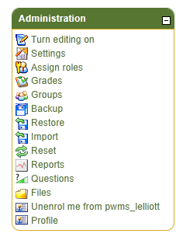
- Click “Student” to see all of the participants enrolled in your course as students.
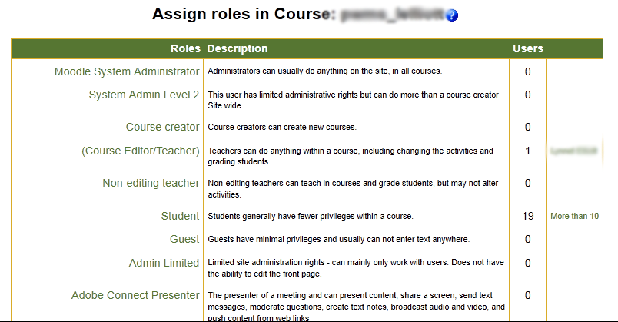
- All of the students enrolled in your course will appear on the left-hand side of your screen. The student(s) you wish to remove need to be hi-lighted in blue. To select more than one students hold the control button while selecting names.

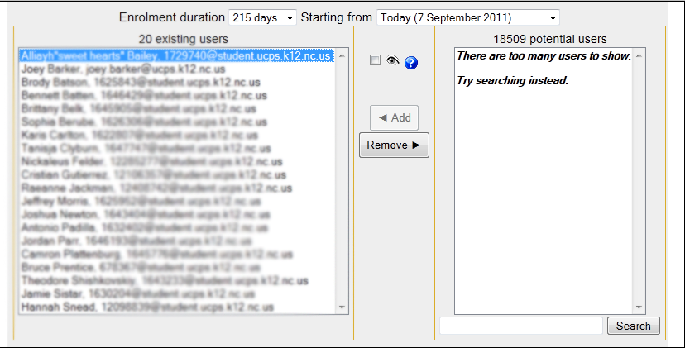
- Click Remove and those students will be un-enrolled from your course.

- Finally click “Assign Roles in Course” and this will enable your changes.

