- Go to the YouTube Video you wish to embed (Use Internet Explorer, b/c YouTube doesn’t work right in Firefox)
- Click Share under the video
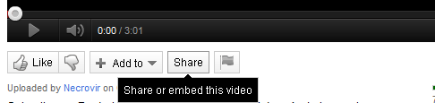
- Click “Embed”
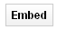
- Copy the Html embed code
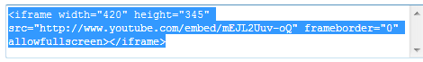
- Go to your Moodle page and turn editing on
- Compose a new webpage (From your “Add a resource” drop-down menu)
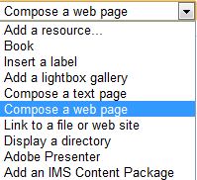
- Fill in all of the necessary information Moodle requires such as “Name” and “Full text”. Under the “Full text” Block click “< >” to enter the html code.
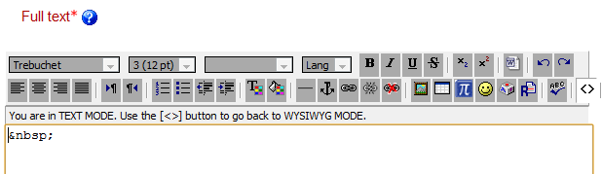
- Paste the embed code you copied from YouTube.
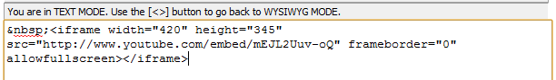
- Click “< >” to exit the html entering mode
- Once you close the html mode, your YouTube video should appear. (If you are editing in Firefox, the video may not appear to work. Double check to see if it appears in Internet Explorer after you save the changes.)
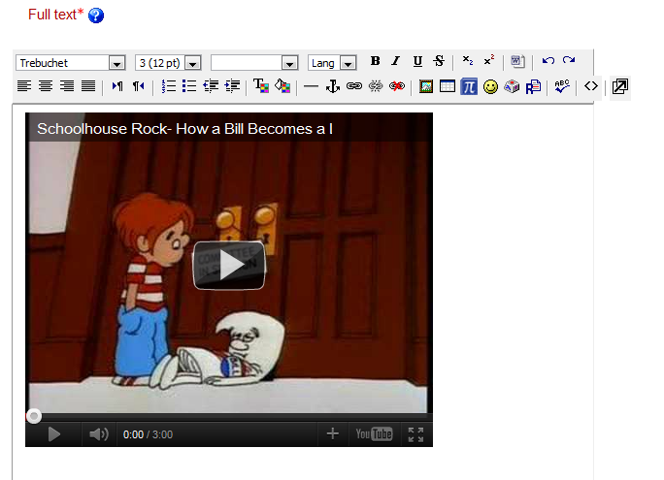
- Click “Save and return to course”
