Creating Groups and Groupings in Moodle
- Log in to your Moodle page

- Go to the “Administration Block” and click “Groups”
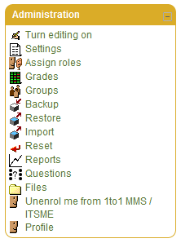
- Click “Create group”
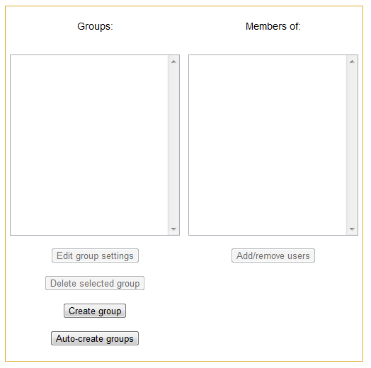
- Type in “Group name.” An enrollment key can also be set to automatically have students enroll in the course and become a member of the group. Once done, click “Save changes.”
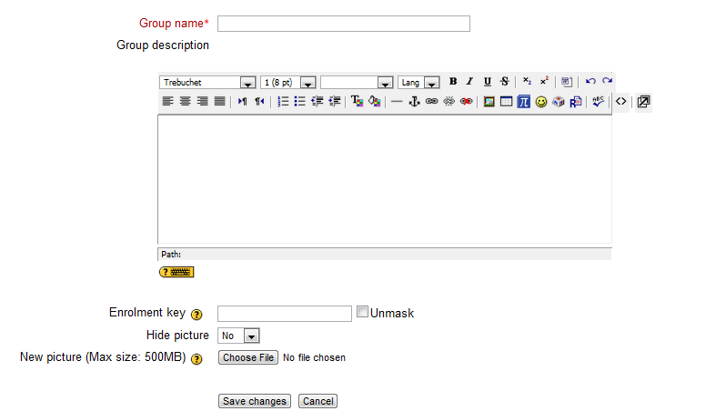
An enrollment key will allow students to enroll as a member of the group. If a teacher does not set an enrollment key, students will need to be manually enrolled in the group.
- “Add/remove users to your group(s)
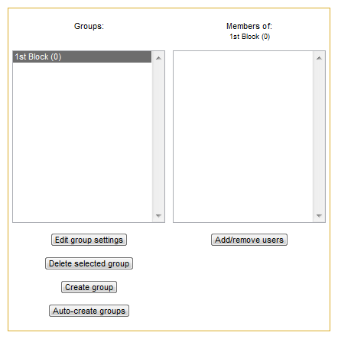
- All students enrolled in your course will appear in the right hand column. To add students to the group, select their name(s) and click “Add.” Then click “Back to groups” to create other groups.
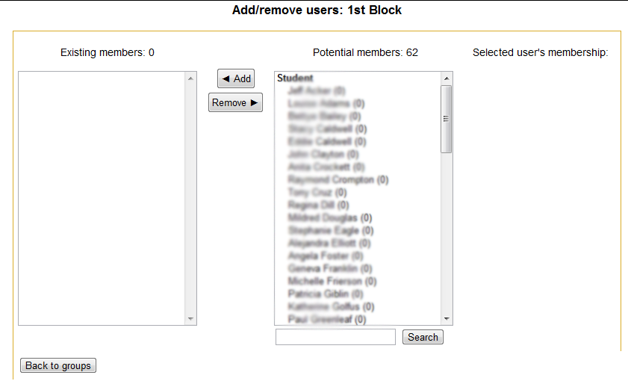

- After you have created groups, you might also want to create groupings. Group modes only apply to certain activities such as forums, but groupings can be applied to any item in Moodle only allowing the specified grouping to see and interact with the activity or resource. To create a grouping, go back to the “Administration block” on your page and click “groups.” At the top of the page you will have three tabs: groups, groupings and overview, click “groupings.”
- Click “create grouping”
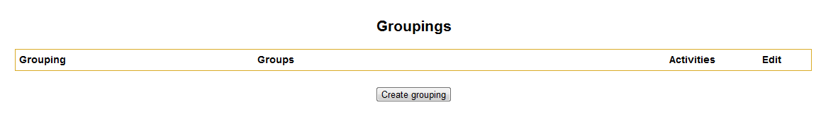

- Name your grouping and save changes. (Groupings can be named to match the groups you have already setup).
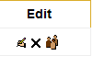
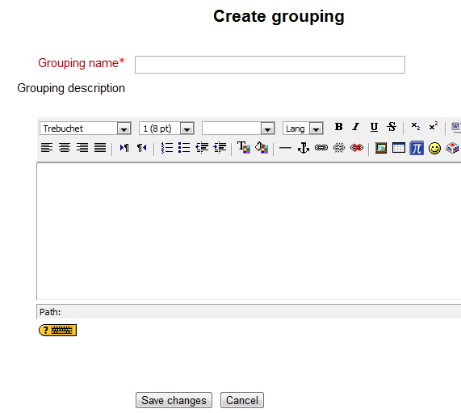
- Click the icon with the group of people (show groups in groupings)

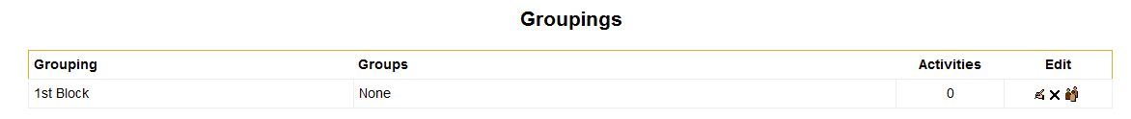

- Add your group(s) to your grouping(s). In the right hand column, all the groups that have been created will appear. You can select the group(s) and add them to your grouping by hi-lighting the group and clicking “Add.” Then click “Back to groupings. Do this same process for other groups and groupings.
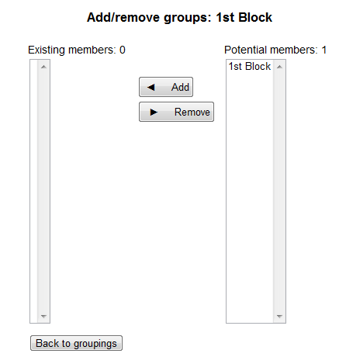

- To make a resource or activity only available to a certain grouping, either create or edit an activity or resource. Scroll down to where it says “Common module settings” and click “Show Advanced”
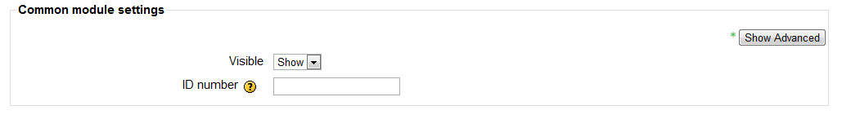
- Options for grouping will appear. Check the box for “Available for group members only” and then choose the grouping you want the item to be available for, from the drop-down menu. Save changes and return to the course.

