Creating Flash Cards in Moodle
- Turn editing on in your Moodle page and “Add an activity…” “Flash Card Set”
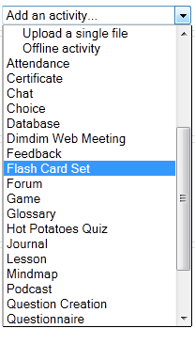
- Fill out the required boxes such as “Name.” The name will be what appears to the flashcard set for your students.
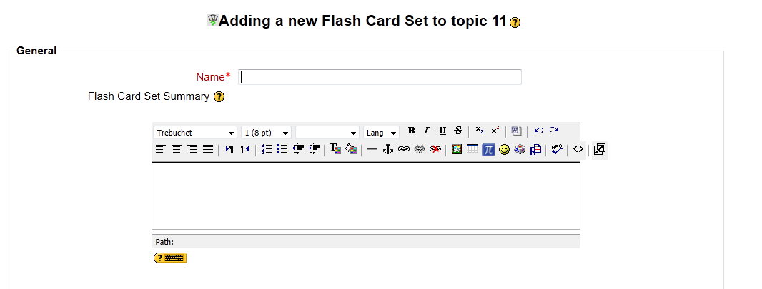
- You have other options that you can change such as the number of decks, when they are available, etc. You can change these settigns to your liking or just go with the defaults. When you are done, select “Save and return to course.”
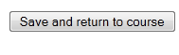
- On your Moodle Page find the flashcard set you created and click the link
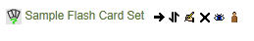
- Click “Edit the cards”
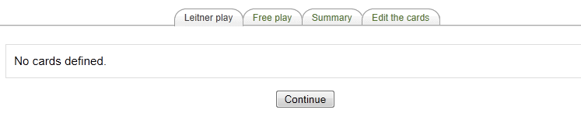
- Now add a new question (flashcard item) or 3 questions
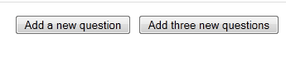
- Type in your question (word) and answer (definition)
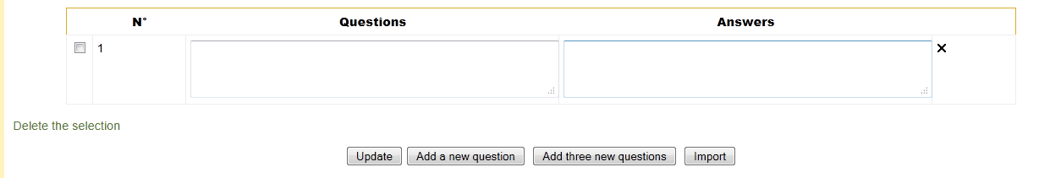

- When you are done putting your word click “Add a new question” to add more questions, or update to complete inputting your words.
- After you have clicked “update.” You will then see your flashcard set. Students have two options of “Leitner play” and “Free play.”
